EXE FILE CREATION

**Pre-required:**

1. **Launch4j application.**
2. **Inno Setup Compiler.**

**Folder structure:**

1. **It was uploaded in the GIT repository refer it.**
2. **Required application for bundling.**
   * 1. jdk-17.
     2. node-v22
     3. postgresql-14

**Steps:**

1. **Backend Exe creation using Launch4j.**
2. **Frontend Build creation using npm command.**
3. **Have the pre-required in the respective folder.**
4. **Using INNO SETUP to bundle and make it as a complete exe.**

**Backend exe creation using launch4j:**

1. Create an *.war* using spring tool suite.
2. Use *launch4j for .exe creation for backend.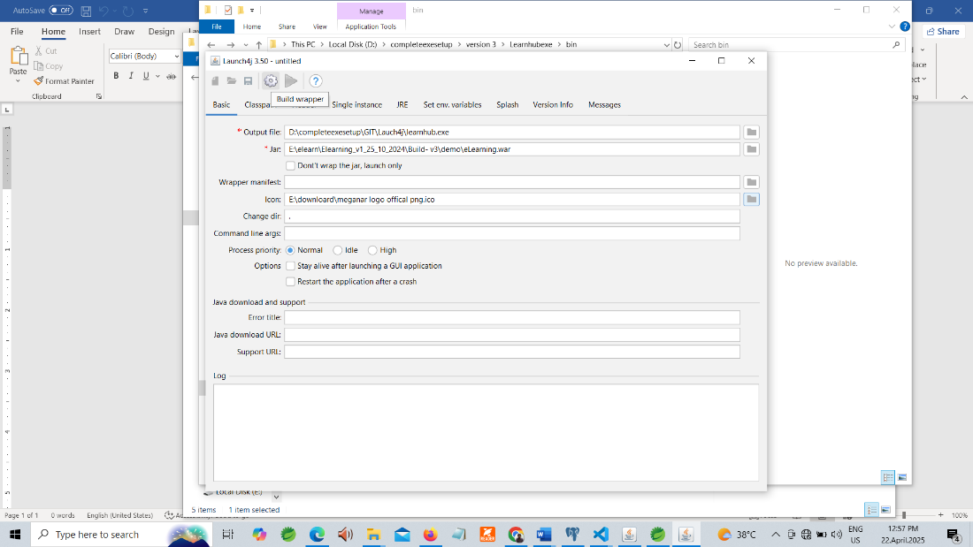*

*Fig 1: launch4j console*

1. *Output File: this is the path where or launch4j exe will be created.*
2. *Jar: Choose the path where the .WAR located*
3. *Icon: Choose the icon file (if needed).*
4. *Click this to create the .EXE*
5. *Save the path where the launch4j script file to save. (It is a dummy file save at anywhere).*

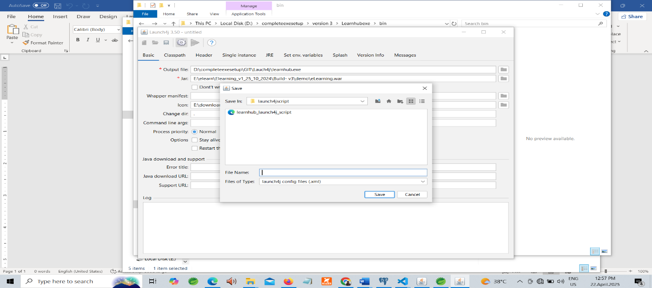

*Fig 2: Screenshot of saving launch4j script file*

1. *If the .exe file created successfully you have the success message. (Check on the path for .EXE file created or not)*

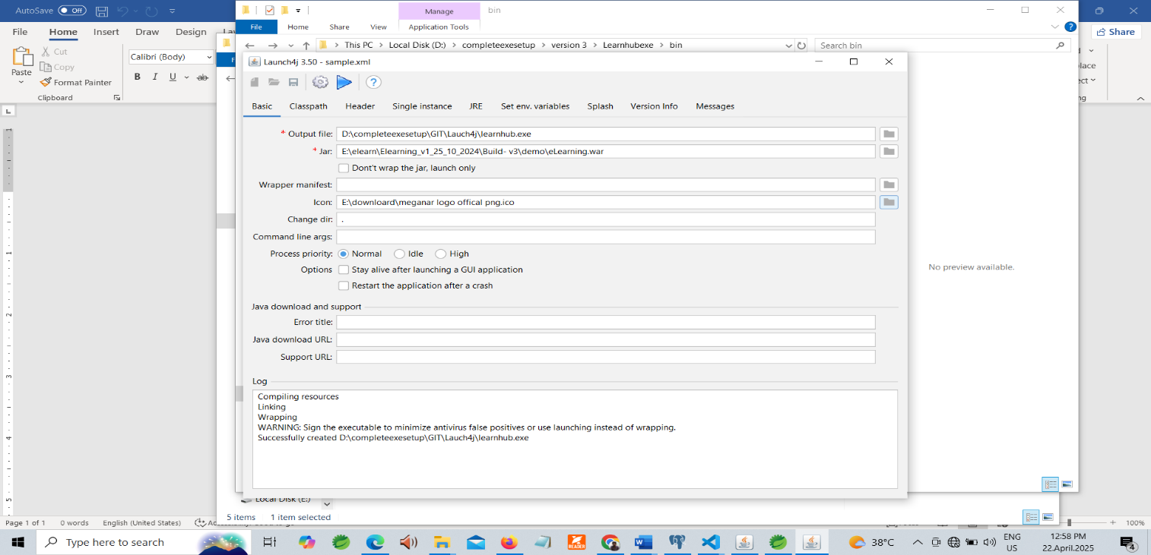

*Fig 3: After creating the exe success message*

**Frontend build creation:**

1. Use ***npm run build*** command to create a build.

**Bundle the required in the .EXE:**

1. Create a required folder structure and have the data from GIT.

**Learnhub:**(*Fig 4)*

|  |  |
| --- | --- |
| **Learnhub🡪** | * **Bin** * **Output** * **completsetupfinal_Learnhub** |

**Inside folders:** (*Fig 5)*

|  |  |
| --- | --- |
| Bin | * **data\**Learnhub_custom_input.txt * **mediaReact\build** * **SQL\14** * **Learnhub_setup.bat** * **learnhub_start.bat** * **learnhub_stop.bat** * **jdk-17.** * **learnhub.exe (create using launch4j)** * **node-v22** * **postgresql-14** |
| Output | * **Location where the .exe file will be created.** |
| InnoScript file | * **The inno script execute using inno setup compiler for bundelling** |

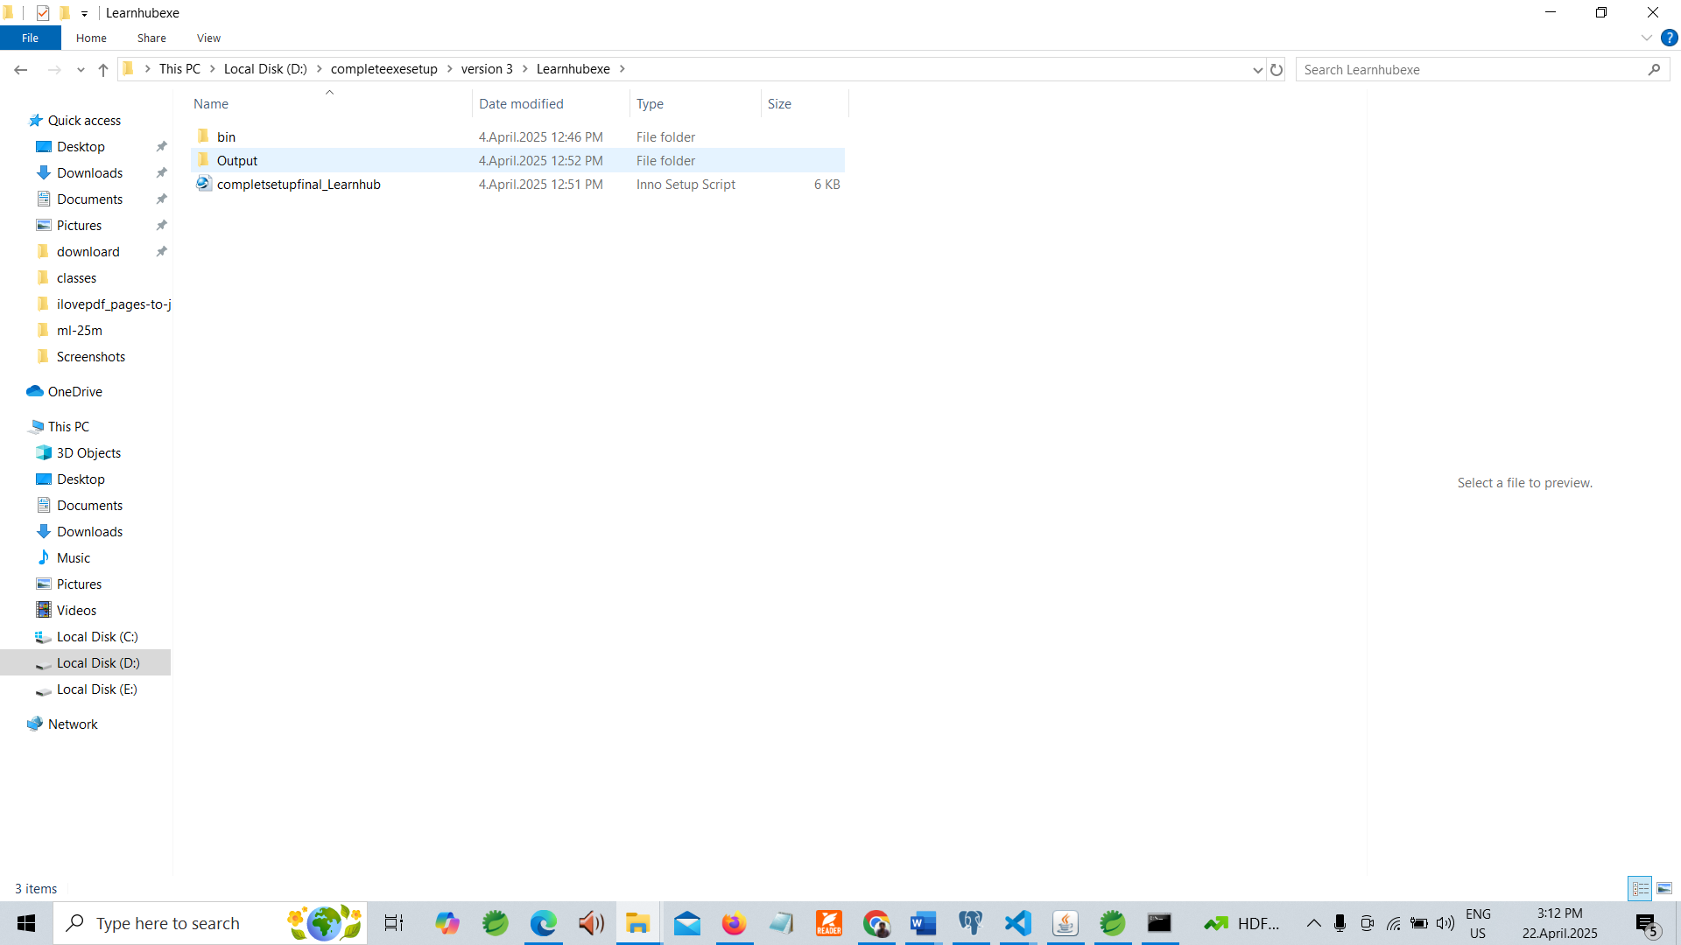

*Fig 4: Outer Folder structure learnhub*

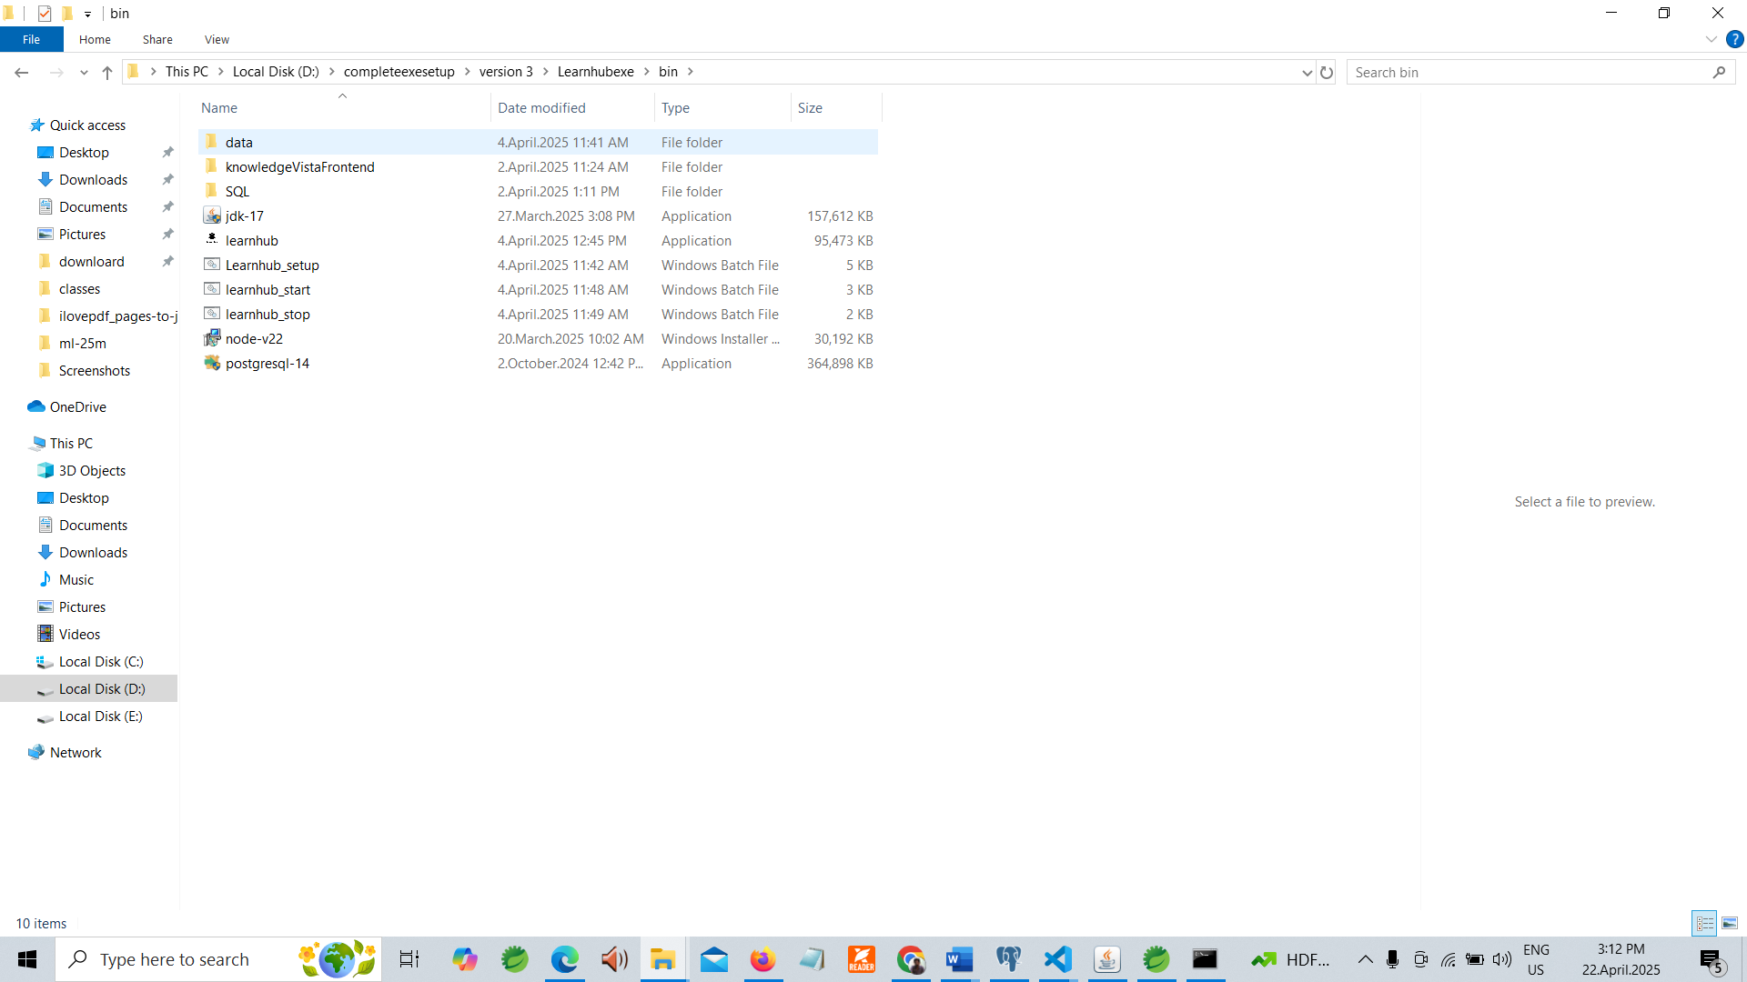

*Fig 5: Inner Folder structure learnhub*

**Mediajungle:** *(Fig 6)*

|  |  |
| --- | --- |
| **Mediajunle🡪** | * **Bin** * **Output** * **completsetupfinal_mediajungle** |

**Inside folders:** *(Fig 7)*

|  |  |
| --- | --- |
| Bin | * **data\** media_custom_input.txt * **mediaReact\build** * **SQL\15** * **Mediajungle_setup.bat** * **mediajungle_start.bat** * **mediajungle_stop.bat** * **jdk-17.** * **mediajungle.exe (create using launch4j)** * **node-v22** * **postgresql-15** |
| Output | * **Location where the .exe file will be created.** |
| InnoScript file | * **The inno script execute using inno setup compiler for bundelling** |

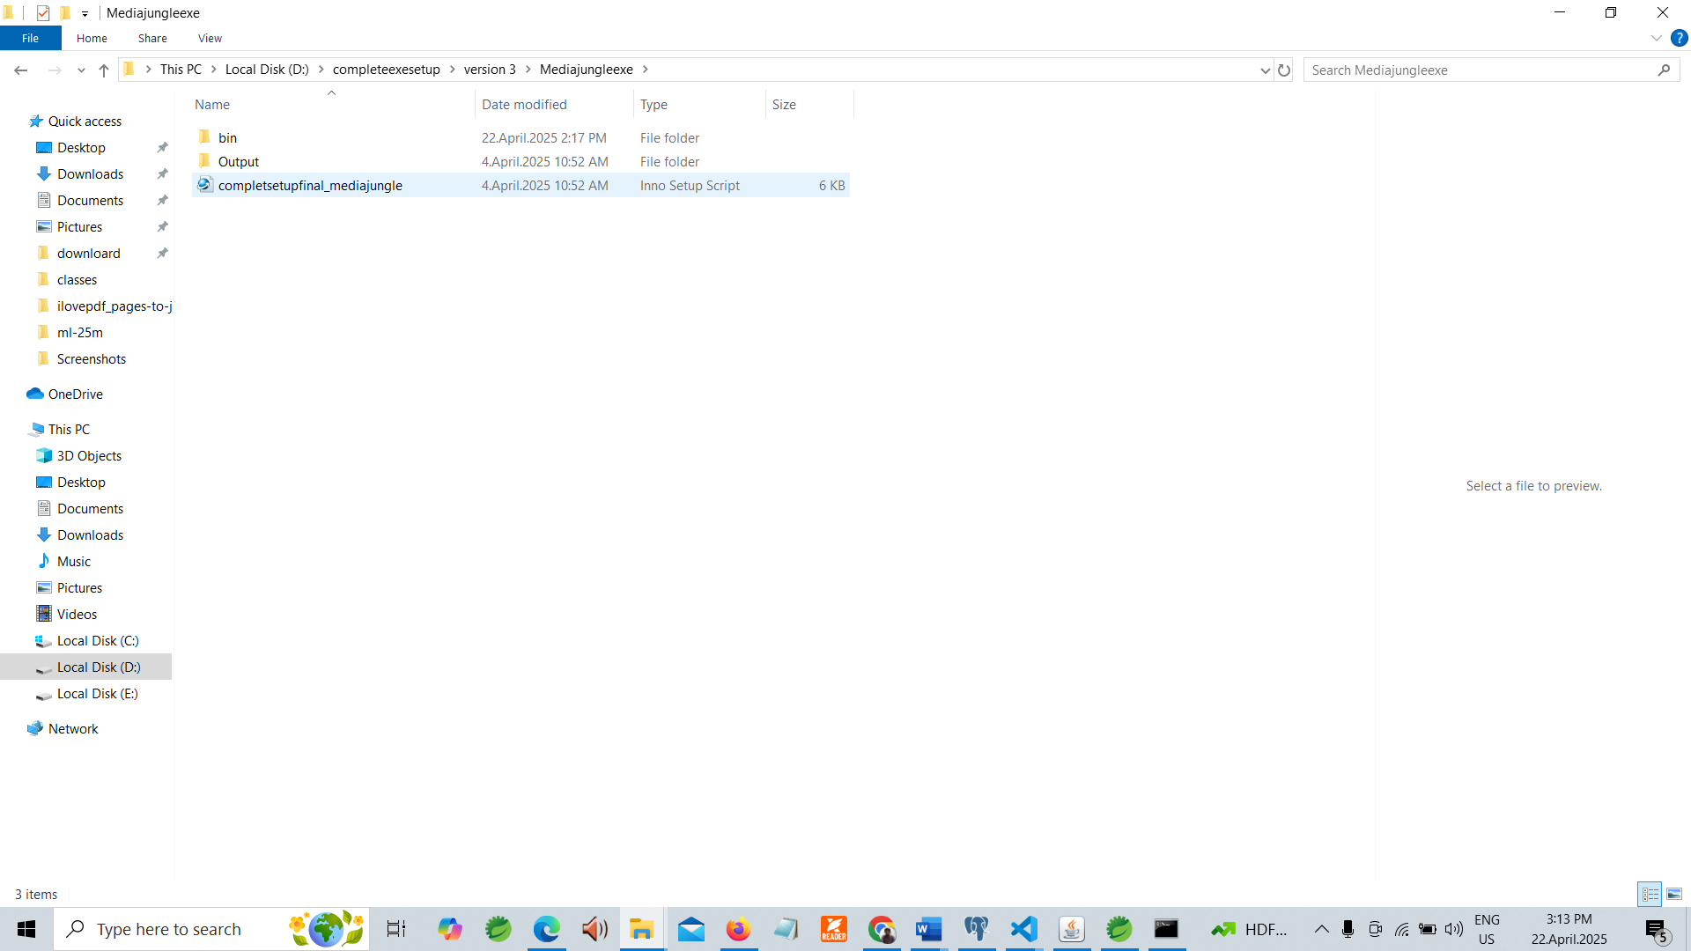

*Fig 6: Inner Folder structure mediajungle*

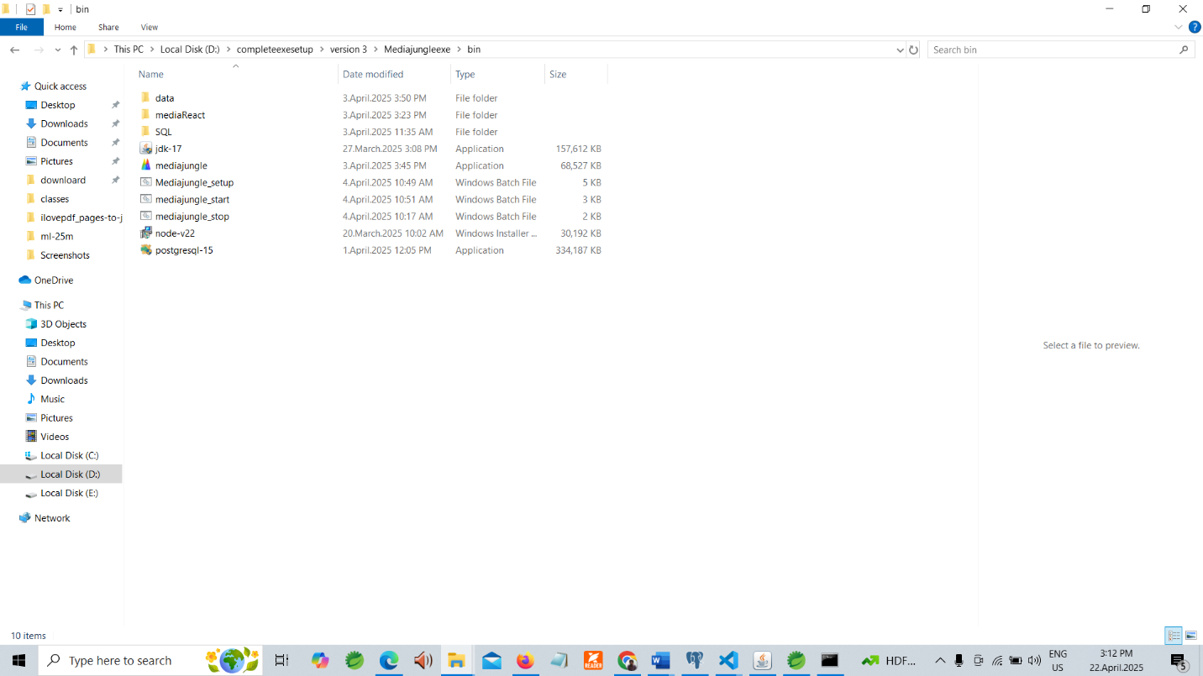

*Fig 7: Outer Folder structure mediajungle*

1. The bat file for has both Learnhub and Mediajungle script files is on their corresponding folders
2. Add the require applications in the **bin** directory which is present in “Learnhub\bin” (OR) “Mediajungle\bin”.
3. Required application:

Learnhub

* + 1. jdk-17.
    2. learnhub.exe (create using launch4j)
    3. node-v22
    4. postgresql-14

Mediajungle

1. jdk-17.
2. mediajungle.exe (create using launch4j)
3. node-v22
4. postgresql-15
5. Open the Existing Innoscript file using Inno script compiler and use **compiler** button or **Ctrl+F9** to compile and create exe(*Fig 8*)

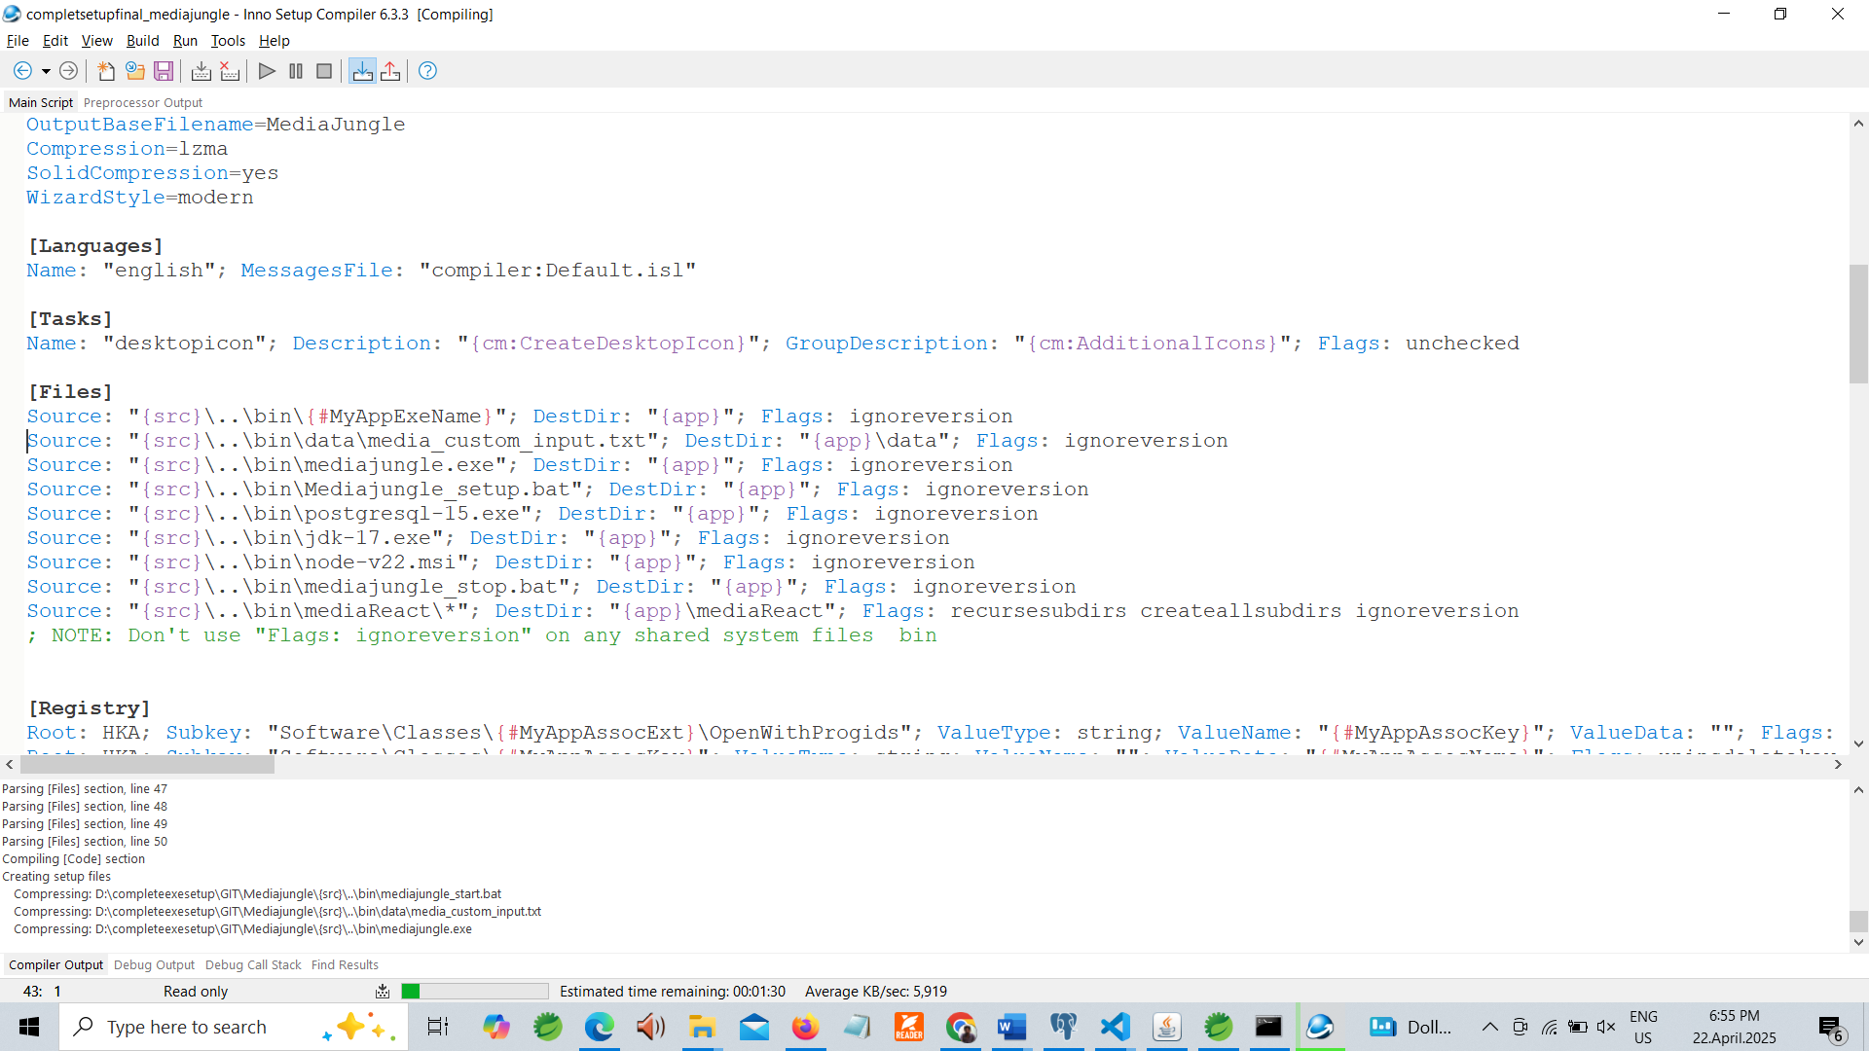

*Fig 8: Inno Setup compiler*

1. The exe script was created on the out put location.

